**LAB 7**

1. The polynomial interpolation for 2,3,4 and 5 pts is shown in the graph below

We see different degree polynomial plots in each cases with increasing accuracy.

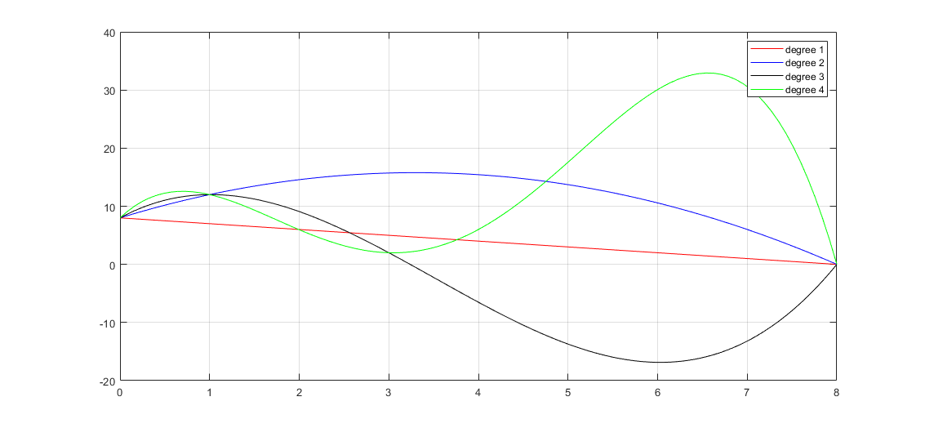

1. Approximate root found out by setting the interpolating polynomial to 0 is 0.408.

Applying newton’s method to find root in the original function, we get root = 0.408

From the graphs, we also see that the root = 0.4 (approx).

Plot for lagrange:

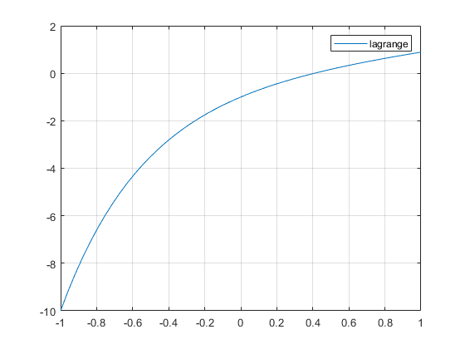

Plot for Newton:

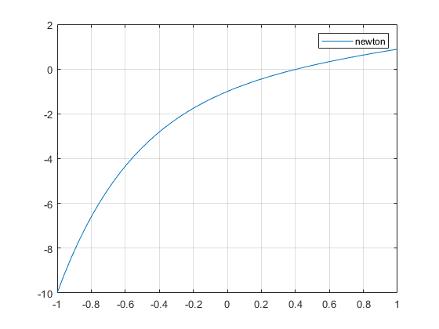

1. Error and corresponding interpolated polynomial for n = 5

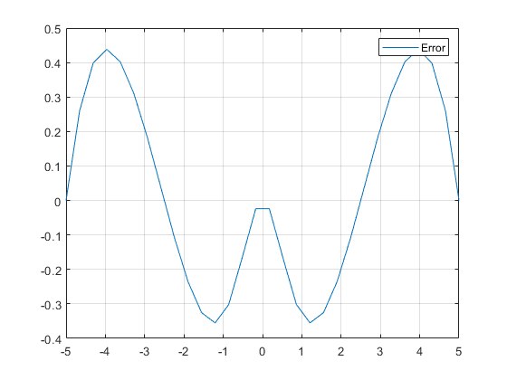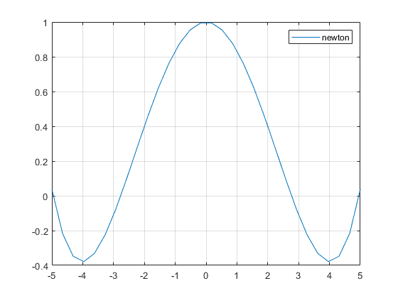

Error and corresponding interpolated polynomial for n = 10

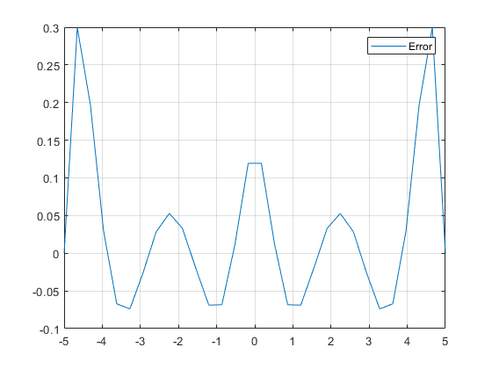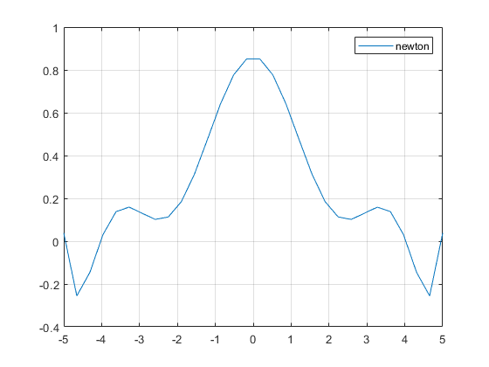

Error and corresponding interpolated polynomial for n = 15

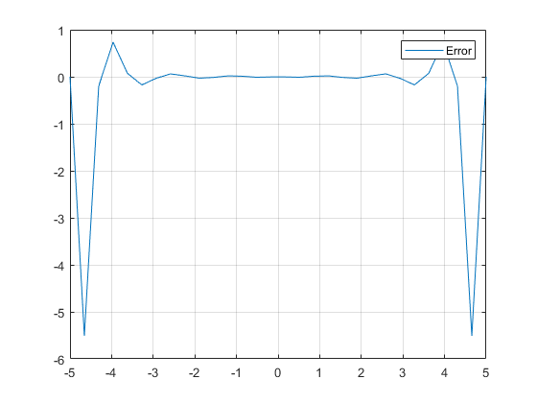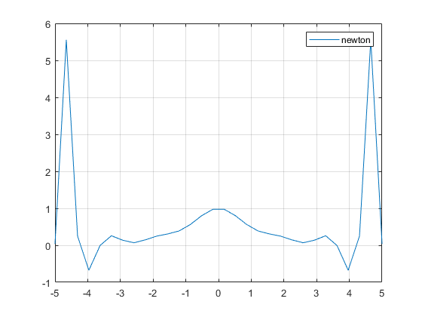

**Hand calculations are attached below:**

